In history, women have always shown less interest in computer science than men. Although this is changing throughout the years, it will take decades and possibly generations for this gap to become equal from males to females. But why is this the case? Is it that women are not capable of doing the same task as men? I believe the reason for this is that women are just not into computer science because of stereotypes.

First, what we observe at a young age plays a big role in the choices we make in our future. Parents play a role in the kid's career choices as mothers are not usually involved with technology while the father is usually the one messing with the computer, playing with the home stereo system, and works in a job involved with tech. [**1**] Just from what is observed in our household can greatly impact our decision-making.

Next, how a computer science person is viewed or in other words stereotyped can influence one’s career choice. In the Science, Engineering, and Medicine (US); they concluded that assumptions and stereotypes about gender caused there to be fewer women pursuing degrees in these fields. [**2**] In a quote (“Starting in the 1980s,” Marie Desjardins says, “computers were marketed entirely to boys. Video games, same thing.” Men gravitated toward the industry, which came to be associated with “wild parties with striptease or nerdy guys in cubicles,” she adds.) [**3**] Assumptions and stereotypical insights greatly influenced women to less likely to get involved in computer science.

Finally, in the two charts below, we can see how over the years in the 70’s women had a higher interest in computer science and as the years gone by it has decreased. Just recently in the past ten years has women started getting more interested in computer science. I believe this may be the case due too computer science being more generalized in college. And not because women have been growing an interest in science all the sudden. We can see that in the SWE chart below also.[**4**]

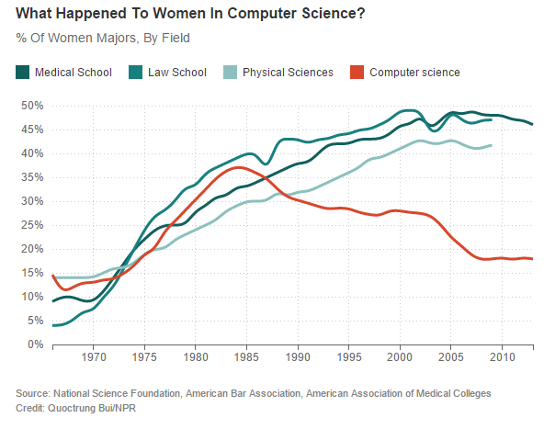

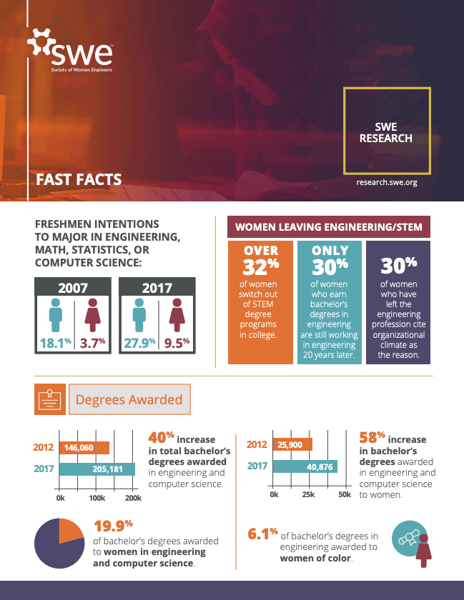

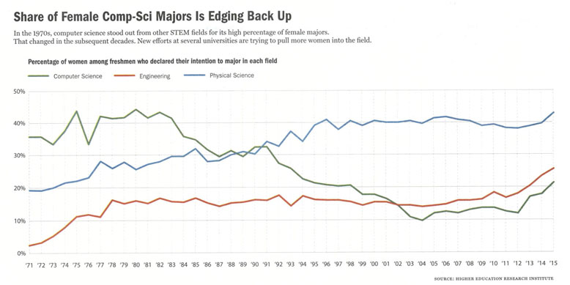

In conclusion, from stereotypes and observance, we are influenced by these very things when it comes to making career choices and other choices in that matter. We see how our parents can influence our decisions just by their everyday tasks and chores they do. We listen to our peers and parents and gather insight into what is acceptable and unacceptable in their eyes. This I believe is the reason why there is such a huge gap between women and men in computer science.

**References**

**[1] Holman, Luke, et al. "The gender gap in science: How long until women are equally represented?" *PLoS Biology*, vol. 16, no. 4, 2018, p. e2004956. *Gale In Context: Opposing Viewpoints*, gale.com/apps/doc/A536809473/OVIC?u=nhc_main&sid=OVIC&xid=8f3bebbe.**

**[2] Carlson, Scott. "Wanted: Female Computer-Science Students." *The Chronicle of Higher Education*, vol. 52, no. 19, 2006. *Gale In Context: Opposing Viewpoints*, gale.com/apps/doc/A147067497/OVIC?u=nhc_main&sid=OVIC&xid=496525d0.**

**[3] Gluckman, Nell. "Steering More Women to Silicon Valley." *The Chronicle of Higher Education*, vol. 64, no. 11, 2017, p. A8+. *Gale In Context: Opposing Viewpoints*, gale.com/apps/doc/A515974682/OVIC?u=nhc_main&sid=OVIC&xid=3b22c375.**

**[4] Rincon, Roberta. “SWE Research Update: Women in Engineering by the Numbers.” *All Together*, Research, 1 Nov. 2019, alltogether.swe.org/2019/11/swe-research-update-women-in-engineering-by-the-numbers-nov-2019.**